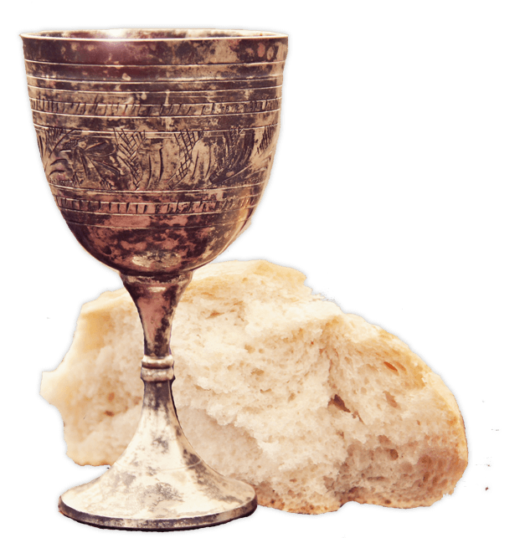
#Communion Celebration Bible Study Notes
Reflective Reading: (1 Corinthians 11:23-32)
www.acts433.com
“For I received from the Lord what I also passed on to you: The Lord Jesus, on the night he was betrayed, took bread, and when he had given thanks, he broke it and said, “This is my body, which is for you; do this in remembrance of me.” In the same way, after supper he took the cup, saying, “This cup is the new covenant in my blood; do this, whenever you drink it, in remembrance of me.” For whenever you eat this bread and drink this cup, you proclaim the Lord’s death until he comes. So then, whoever eats the bread or drinks the cup of the Lord in an unworthy manner will be guilty of sinning against the body and blood of the Lord. Everyone ought to examine themselves before they eat of the bread and drink from the cup. For those who eat and drink without discerning the body of Christ eat and drink judgment on themselves. That is why many among you are weak and sick, and a number of you have fallen asleep. But if we were more discerning with regard to ourselves, we would not come under such judgment. Nevertheless, when we are judged in this way by the Lord, we are being disciplined so that we will not be finally condemned with the world.”
Slide 1: Whenever the children of Israel would sacrifice a ______________
for a burnt offering __________________ was theirs. This was common to
do especially when facing a strong enemy, who should have defeated the
Israelites.
Slide 2: Today, we proclaim Jesus’ death and our victory simply by
partaking of the Lord’s ___________________ (1 Corinthians 11:26).
_________________ is a victory feast, a celebration enjoyed by the faith of
the children of the Victorious God.
For if we would judge/(diakrino) ourselves, we should not be judged/(krino) [1 Corinthians 11:31]. Diakrino means learn to decide and krino means to chose.
Slide 3: So what 1 Corinthians 11:31 is saying is that we should judge
ourselves in light of Christ’s __________________ sacrifice. Because of
Jesus’ body and blood that was shed you are forgiven and healed. We are to
decipher what is from God (healing) and what is part of sin’s curse
(sickness).
Proper Understanding of Communion

Slide 4: In communion, the _________________ represents Jesus body
which was given so that you might have life and health. The ____________
represents the forgiveness of sins made available by the blood Jesus shed
for us.

Slide 5: “Because they were not judging themselves in light of the finished
work of the cross (forgiven, accepted, blessed, healed), they were still
experiencing the punishing effects of sin (rejection, sickness,
condemnation). Because they weren’t attributing to Christ the full worth of
his ___________________, they were still ______________________.”

Paul Ellis. Taking Communion in an Unworthy Manner. https://escapetoreality.org/2011/04/10/taking-communion-in-an-unworthy-manner/

